Driving Directions to meet our bus in Nerang for your ballooning experience with Hot Air

Useful phone numbers:

Office (Available 3.30am-6am and 8am-8pm) – 1300 766 887 – Please quote your 6 figure booking reference number when you call.

Important – Please call us if you are running late and make sure that you have given us YOUR MOBILE PHONE NUMBER.

If driving down the M1 take exit for Nerang South or Nerang North and head into Central Nerang. Nerang Fair is the Shopping Centre on the road to Beaudesert, next to the 7/11 petrol station and has Coles prominently signed. Our driver will collect you in a bus from the Coles Carpark at the time you were given when you you’re your reservation. Please DO NOT park in the 7/11 car park.

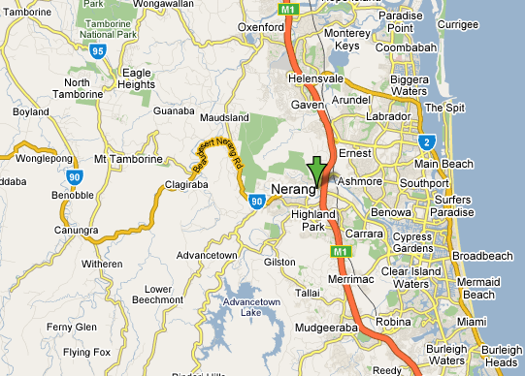

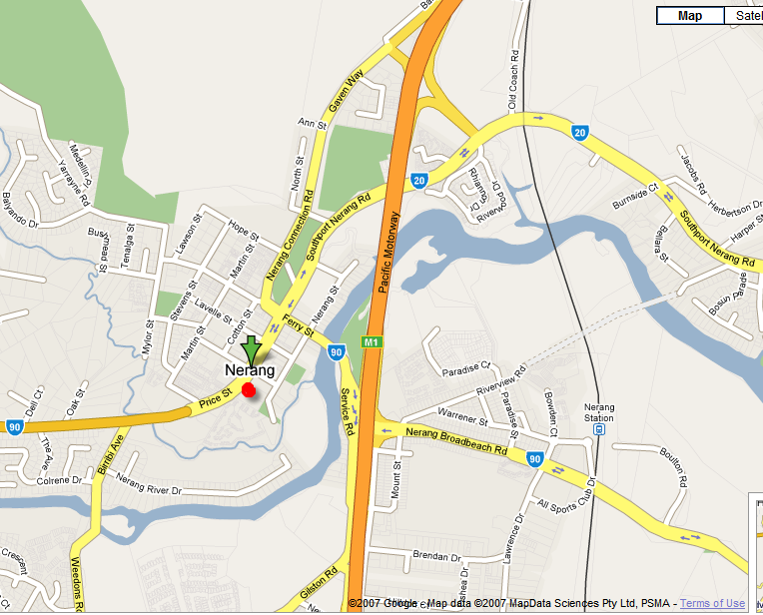

Approximate driving times from:

Dreamworld is 10 minutes
Burleigh is 30 minutes

